Workbench perspective

**Workbench perspective** is the place where the user develops the dynamic applications. This perspective contains all *views* and *editors*(suitable for any file type) that may help in the overall implementation, from domain models via services to the user interface.

Workbench perspective **views**:

* Workspace
* Import
* Properties
* Console
* Preview

Workspace

The main view opened by default in this perspective is the Workspace explorer, a s*tandard view* on the projects in your [*workspace*](http://www.dirigible.io/help/concepts_workspace.html).

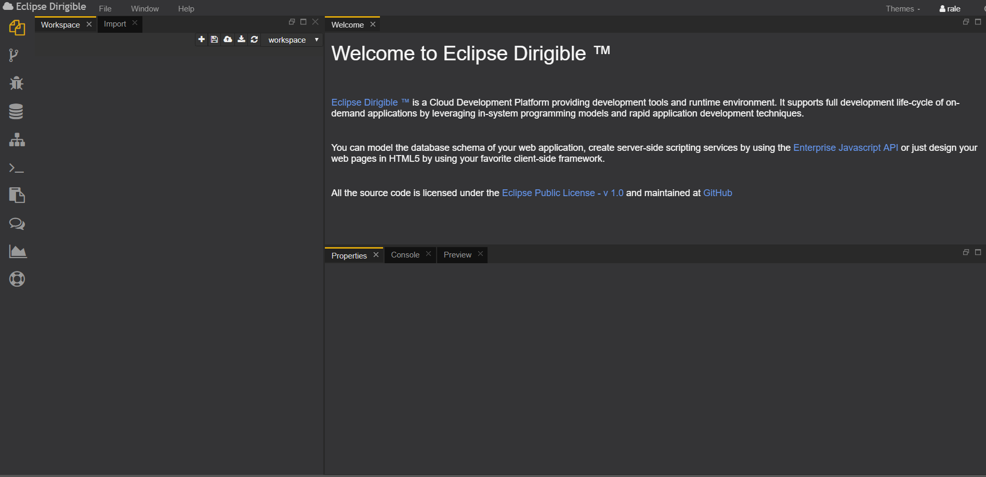

The **Workspace** is the developer’s place where user creates and manages the application artifacts. The first-level citizens of the workspace are the projects. Each project can contain multiple folders and files (artifacts).

A single user can have *multiple workspaces*, containing different set of projects.

Import

The **Import view** enables the user to upload a *.zip file, containing one or more projects, to the selected [Workspace](http://www.dirigible.io/help/ide_view_workspace.html). The view includes a progress bar for navigation of the process. The user can manage and switch between multiple workspaces through the Workspace menu.

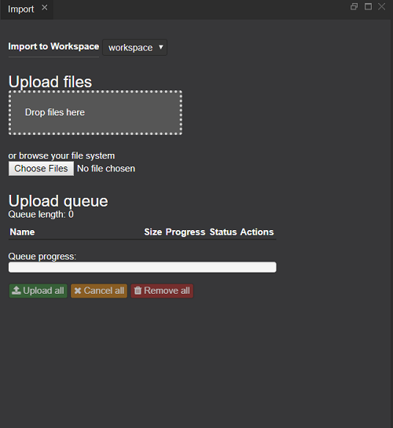

Properties

The **Properties view** allows the user can see the name, path, type, and the content of a file chosen by him.

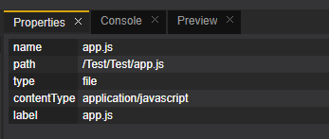

Preview

The **Preview view** displays the result of executing the selected file. It refreshes automatically during Workspace change events e.g. Save.

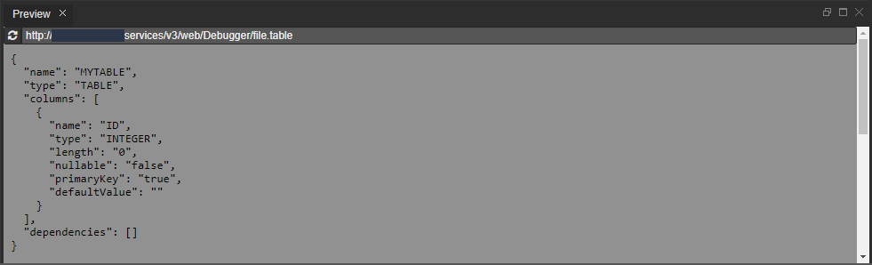

Console

The **Console view** is a major debugging tool. It displays the output of the code that you are executing.

